DISCRETE STRUCTURES
SOLUTION 1

- Let x be any general element of A, then 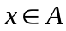. Also 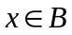, as 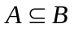. Now as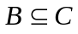, then 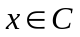. Therefore any element of A also belongs to C. Hence 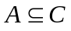.
- 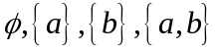.
- Let A be the set of people eating fruits, B be the set of people eating vegetables and C be the set of people eating cheese, D be the set of people eating only cheese and E be the set of people who do not eat any of the three offerings . According to the problem,
A = 37, B = 33, C = ?, D = 12, E = ?
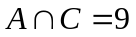, 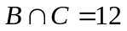, 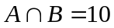, 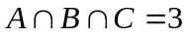
Also
C = 12 + 12 + 9 – 3 = 30
i.e. 37 + 33 + 30 – 10 – 12 – 9 + 3 + E = 100
i.e. E = 100 – 103 + 31, i.e. E = 28.
Therefore the number of people who eat cheese is 30 and the number of people who do not take any of the three offerings is 28.
- Let 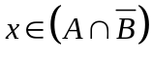 so and 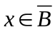 i.e. 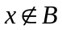. Since and so 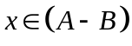. Since every element x that belongs to 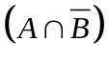 also belongs to 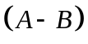. So 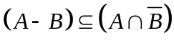. Similarly we can prove that 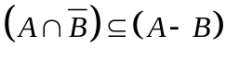. Hence 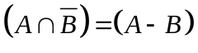.
- a). a, +, , b are REs over A as they all belong to A.
Now, we list all the REs over A in successive orders:
RE1: 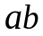
RE2: 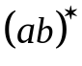
RE3: 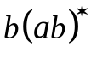
RE4: 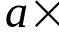
RE5: 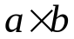
RE6: 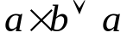
RE7: 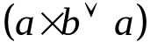
RE8: 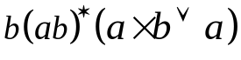
RE9: 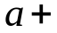
RE10: 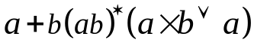.
b). Proceed in the same way as part (a).
c). Proceed in the same way as part (a).
- If c divides a and b, it divides 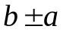 (Prove yourself).
Since a = b – (b – a) = -b + (b + a), we see that a common divisor of b and also divides a and b. Since a and b have the same common divisors as b and , they must have the same greatest common divisor.
- Let 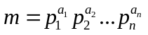 and 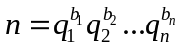
where 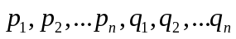 are all distinct. If mn is a perfect square, then, 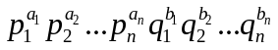 is a perfect square. Also as all of are distinct, so all the powers 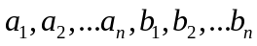 must be even. So m and n both are perfect squares.
- Let 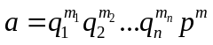 and 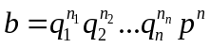. Then
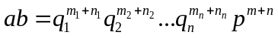. Since 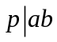, so 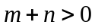. For that either 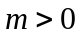 or 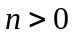. So if then 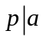 or if then 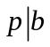.
- 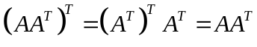 , hence 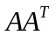 is symmetric.
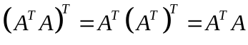, hence 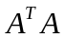 is also symmetric.
- Let 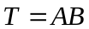, Premultiplying both sides by 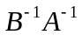, we get,
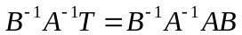= 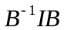 = 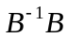 = .= . Similarly we can show
that 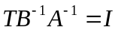, so 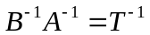, but so 

